**AND GATE truth table:**

|  |  |  |
| --- | --- | --- |
| **Pin 1** | **Pin 2** | **Output** |
| **0** | **0** | **OFF** |
| **0** | **1** | **OFF** |
| **1** | **0** | **OFF** |
| **1** | **1** | **ON** |

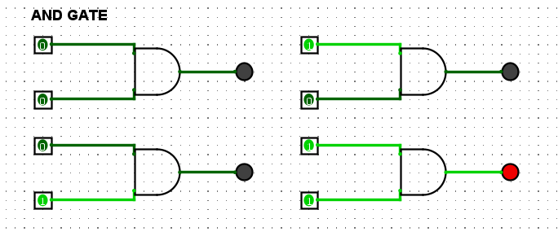

**NOT GATE truth table:**

|  |  |
| --- | --- |
| **Pin** | **Output** |
| **0** | **ON** |
| **1** | **OFF** |

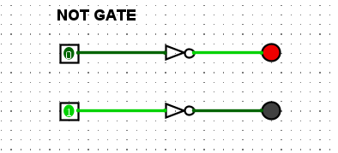

**XOR GATE truth table:**

|  |  |  |
| --- | --- | --- |
| **Pin 1** | **Pin 2** | **Output** |
| **0** | **0** | **OFF** |
| **0** | **1** | **ON** |
| **1** | **0** | **ON** |
| **1** | **1** | **OFF** |

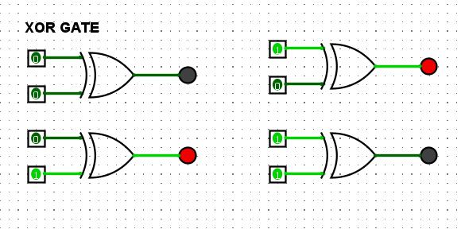

**Question 12**

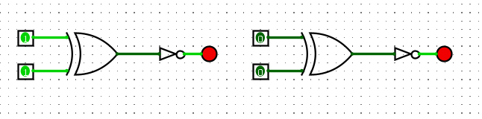

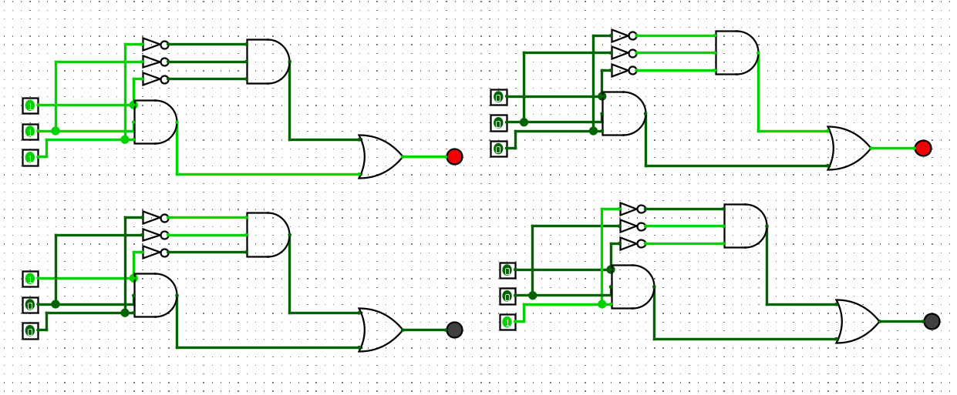 **Question 15 ( 3 way input**